**Brain WebQuest**

Use any or all of the following sites to complete the questions below

<http://science.nationalgeographic.com/science/health-and-human-body/human-body/brain-article.html>

* Note - you will need to click “interior” to see the inner structures.

<http://www.pbs.org/wnet/brain/3d/>

<http://www.waiting.com/brainanatomy.html>

<http://www.pbs.org/wgbh/pages/frontline/shows/teenbrain/work/anatomy.html>

*Explain in your words the function of each of the following parts of the brain. In addition, label all parts on the diagrams provided.*

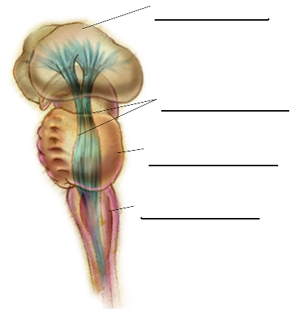Part I: Structures of the brain – Label each brain structure (if applicable) and explain its function.

Brainstem

Medulla

Pons

Reticular Formation

Thalamus

Cerebellum

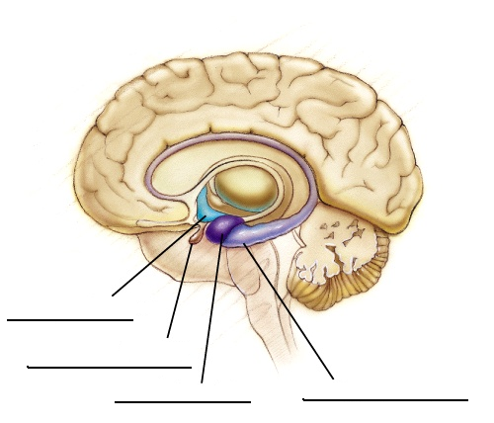

Limbic System

Hypothalamus

Amygdala

Hippocampus

Pituitary Gland

Pineal Gland

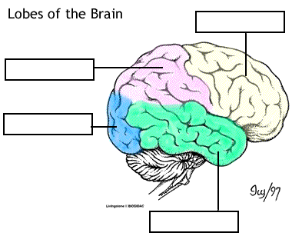Part II: Cerebral Cortex:

Parietal Lobe

Occipital Lobe

Frontal Lobe

Temporal Lobe

Part III: Methods of Studying the Brain. Go to: <http://www.pbs.org/wnet/brain/scanning/index.html>

Briefly explain the following and provide at least one benefit for using each respective brain scan:

EEG -

CAT -

PET -

MRI -

Part IV: Hemispheric Specialization

<http://bcs.worthpublishers.com/gray/content/psychsim5/launcher.html>

Click on “Hemispheric Specialization” near the bottom of the options. Complete the tutorial, taking some time to complete the answers.