“The Three Brains”
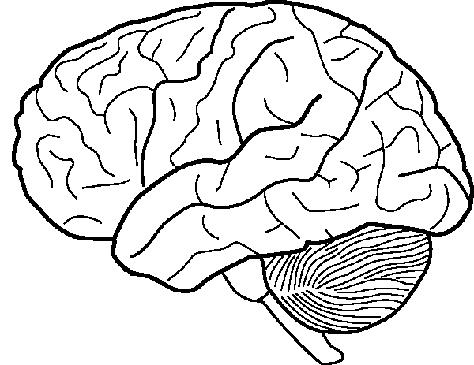
The Four Brain Lobes
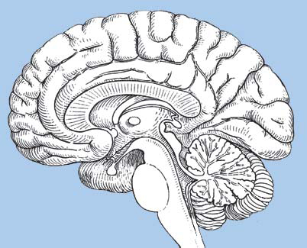
In the Diagram Above, Label the Following:
Medulla
Cerebrum
Pons
Reticular Activating System
Thalamus
Hypothalamus
Cerebral Cortex
Corpus Callosum
Amygdala
Hippocampus

